MANUSCRIPT TEMPLATE — INTERNATIONAL JOURNAL OF NURSING & HEALTH SCIENCES
Prepare your submission using the sections below. Replace the italic guidance and the example text with your own content.
Title of the Manuscript Goes Here
▸ A concise, specific, and informative title (ideally under 15 words). Avoid abbreviations and jargon.
Example: The Effect of Adaptive Feedback on Novice Programmers' Debugging Accuracy: A Randomized Study

Authors and Affiliations
▸ List every author in the intended order. For each author provide: full name, affiliation (department, institution), country, and ORCID iD. Mark the corresponding author with an asterisk (*) and give their email.
Jane A. Doe1* · John B. Smith2 · Mei L. Chen1
1 Department of Computer Science, Example University, City, Country. ORCID: 0000-0000-0000-0000
2 Institute of Data Science, Second University, City, Country. ORCID: 0000-0000-0000-0001
* Corresponding author: jane.doe@example.edu

Abstract
▸ A single unstructured paragraph of 150–250 words summarizing the background, objective, methods, key results, and main conclusion. Do not include citations, tables, or undefined abbreviations.
Lorem ipsum dolor sit amet, consectetur adipiscing elit. Background: existing approaches leave a gap that this study addresses. Objective: we set out to measure the effect of a proposed method on a well-defined outcome. Methods: we conducted a controlled study with a representative sample and pre-registered analysis. Results: the intervention produced a statistically significant improvement over the baseline (see Results). Conclusion: the findings support the proposed approach and suggest concrete directions for practice and future work.

Keywords
▸ Provide 3–6 keywords separated by semicolons, ordered from general to specific. Prefer recognized index terms.
adaptive feedback; programming education; debugging; randomized study; learning analytics

1. Introduction
▸ State the problem and why it matters, summarize the relevant prior work, identify the gap, and end with the objectives or hypotheses of the study.
Lorem ipsum dolor sit amet, consectetur adipiscing elit, sed do eiusmod tempor incididunt ut labore et dolore magna aliqua. The problem addressed here has broad relevance and has been studied from several angles in prior work. Ut enim ad minim veniam, quis nostrud exercitation ullamco laboris nisi ut aliquip ex ea commodo consequat. Despite this, a clear gap remains, which motivates the present study. In this article we aim to close that gap by pursuing the objectives set out below.

2. Methods and Materials
▸ Describe the design, materials, participants or data, procedures, and analysis in enough detail that an independent researcher could reproduce the study. Cite instruments, software versions, and statistical methods.
Duis aute irure dolor in reprehenderit in voluptate velit esse cillum. We describe the study design, the sample, and the measures used, together with the procedure followed during data collection. Excepteur sint occaecat cupidatat non proident, sunt in culpa qui officia deserunt mollit. All analyses were performed with named, versioned software, and the analysis plan was fixed in advance.

3. Results
▸ Report findings objectively, without interpretation. Refer to figures and tables explicitly, e.g. "(Figure 1)" or "(Table 1)". Report effect sizes and uncertainty, not only p-values.
The primary analysis showed a clear effect of the intervention on the outcome of interest (Figure 1). Group differences were consistent across the pre-specified subgroups, and the associated confidence intervals excluded the null. Sed ut perspiciatis unde omnis iste natus error sit voluptatem accusantium doloremque laudantium.
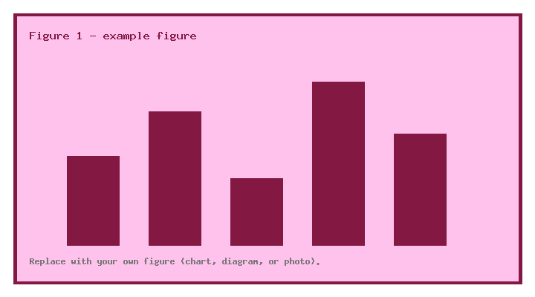
Figure 1. Descriptive caption goes here — state what the figure shows and define any symbols or units.

4. Discussion
▸ Interpret the results in light of the objectives, compare them with prior work, acknowledge limitations, and explain the practical or theoretical implications.
Our findings are consistent with earlier reports while extending them in an important direction. Nemo enim ipsam voluptatem quia voluptas sit aspernatur aut odit aut fugit. Several limitations temper these conclusions and point to the need for replication. Neque porro quisquam est, qui dolorem ipsum quia dolor sit amet, consectetur, adipisci velit.

5. Conclusion
▸ State the main contribution in one or two sentences and outline concrete directions for future work. Do not introduce new results here.
This study contributes a validated approach to the stated problem and demonstrates its effect under controlled conditions. Future work should test generalization to other settings and populations, and explore the mechanisms underlying the observed effect.

Declarations
Funding
▸ State all sources of funding and grant numbers, or declare that no funding was received.
Example: This work was supported by Grant No. 000000 from the Example Foundation.
Conflicts of Interest
▸ Declare any financial or non-financial competing interests, or state that there are none.
Example: The authors declare no competing interests.
Ethics and Consent
▸ Name the approving ethics committee and approval number, and confirm that informed consent was obtained where applicable.
Example: Approved by the Example University IRB (No. 0000); all participants gave informed consent.
Data Availability
▸ State where the data supporting the findings can be found, or explain any access restrictions.
Example: The datasets are openly available at https://doi.org/10.0000/example.

References
▸ List every source cited in the text, formatted consistently in APA 7th style and ordered alphabetically by first author. Include a DOI as a URL where one exists.
Doe, J. A., & Smith, J. B. (2021). Adaptive feedback and debugging accuracy in novice programmers. Journal of Computing Education, 12(3), 210–228. https://doi.org/10.1000/jce.2021.0210
Chen, M. L. (2020). Learning analytics for formative assessment: A systematic review. Educational Technology Research, 68(4), 1455–1479. https://doi.org/10.1000/etr.2020.1455
Garcia, R., & Novak, P. (2019). Reproducibility in empirical software engineering. Empirical Software Engineering, 24(6), 3901–3930. https://doi.org/10.1000/emse.2019.3901
World Health Organization. (2018). Guidelines for reporting observational studies. WHO Press.

